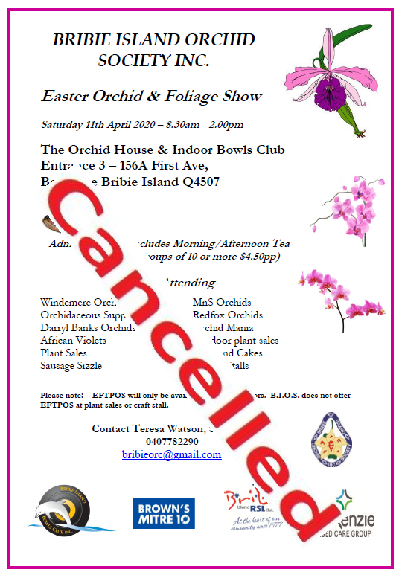

Hi
It is with deep regret that we have decided to cancel our Easter Show due to concerns of the current pandemic.
Orchid growers are probably the most vulnerable age demographic for this virus and we have taken this into our decision.
We will be having our Spring Show in October and further notices will follow
Cheers
Teresa Watson 0407782290

