INVITE YOU TO OUR:
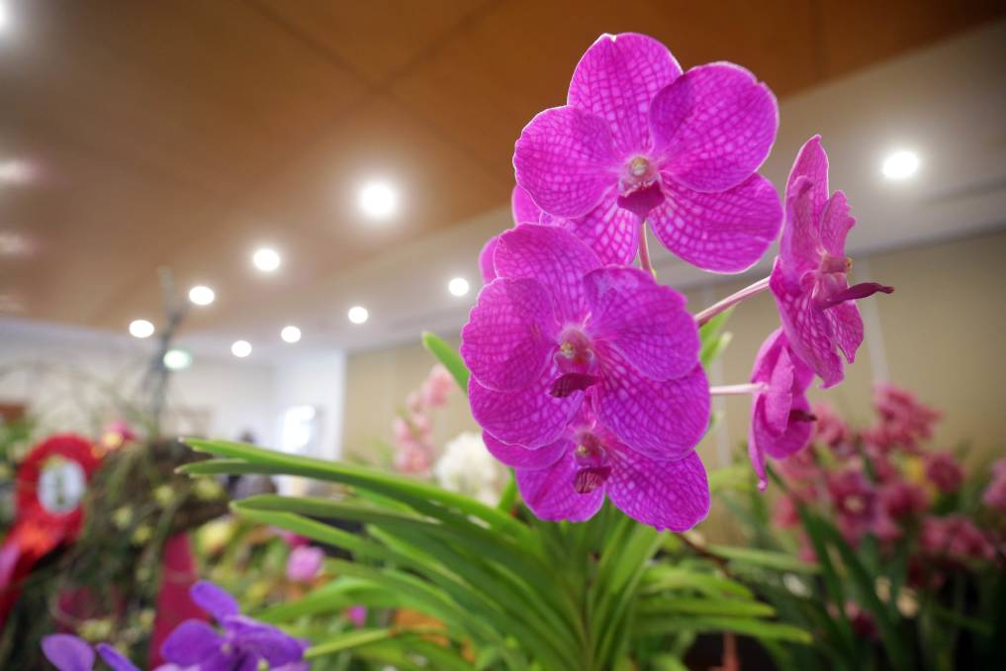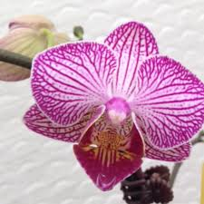
Proceeds go to the RACQ LIFE FLIGHT HELICOPTER
WHERE; ISIS CULTURAL CENTRE
CHURCHILL STREET
CHILDERS
21st March 2020
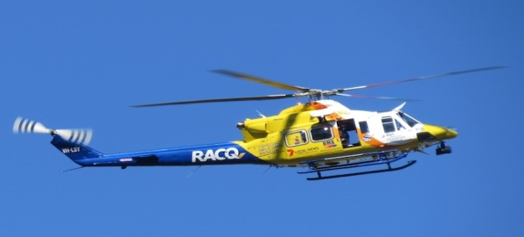
TIME 8:00 am till 2:00 pm
Spectacular Displays
Admission: $2:00 Refreshments Available Orchid potting Demonstration 10:00am
Trophy presentation 2:00pm Lovely raffles to be won
Get all your Orchid Accessories from Orchidaceous Supplies PLUS
Two Orchid Sellers having baby to flowering orchids.Also cactus For Sale
ORCHIDS & OTHER PLANTS FOR SALE
Lots of back street parking
More Info 41266119

